ExNo: 38 /\*HTML FIELDS\*/

PROGRAM:

<html>

<head>

<style>

input[type=text]

{

background-color:brown;

}

input[type]=password

{

background-color:green;

}

</style>

</head>

<body>

<p><b>ENTER YOUR DETAILS BELOW</b></p>

<div>

<form>

<label for="0">name</label>

<input type="name" id="0" name="0" ><br>

<label for="1">password</label>

<input type="password" id="1" name="1">

</form>

</div>

</body>

</html>

OUTPUT:

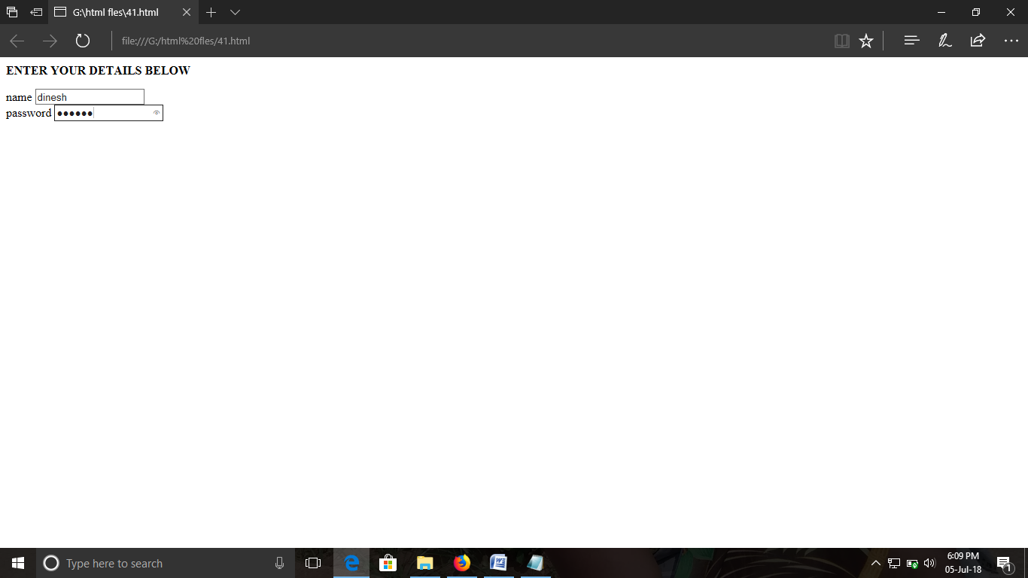

ExNo:39 /\*HTML PASSWORD\*/

PROGRAM:

<html>

<head>

<style>

input[type=text]

{

background-color:red;

}

input[type]=password

{

background-color:green;

}

</style>

</head>

<body>

<p><b>ENTER YOUR ID AND PASSWORD</b></p>

<div>

<form>

<label for="1">email id</label>

<input type="email id" id="1" name="1"><br>

<label for="0">password</label>

<input type="password" id="0" name="0">

<input type="submit" id="0" value="submit">

</form>

</div>

</body>

</html>

OUTPUT:

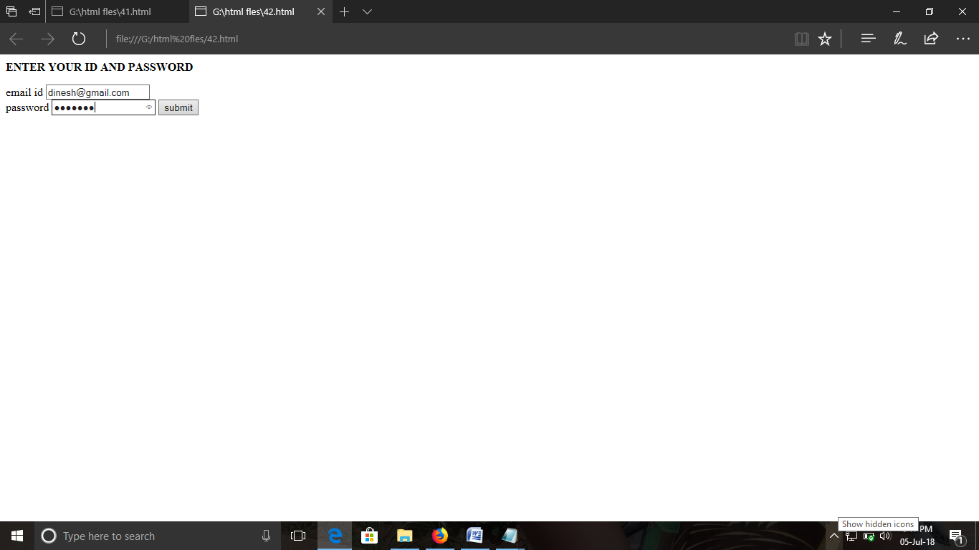

ExNo:40 /\*HTML SUBMIT\*/

PROGRAM:

<html>

<head>

<style>

input[type=text]

{

background-color:red;

}

</style>

</head>

<body>

<p><b>ENTER YOUR MESSAGE HERE</b></p>

<div>

<form>

<label for="1">message</label>

<input type="text" id="1" name="1"><br>

<label for="0">number</label>

<input type="number" id="0" name="0">

<input type="submit" id="0" value="send">

</form>

</div>

</body>

</html>

OUTPUT:

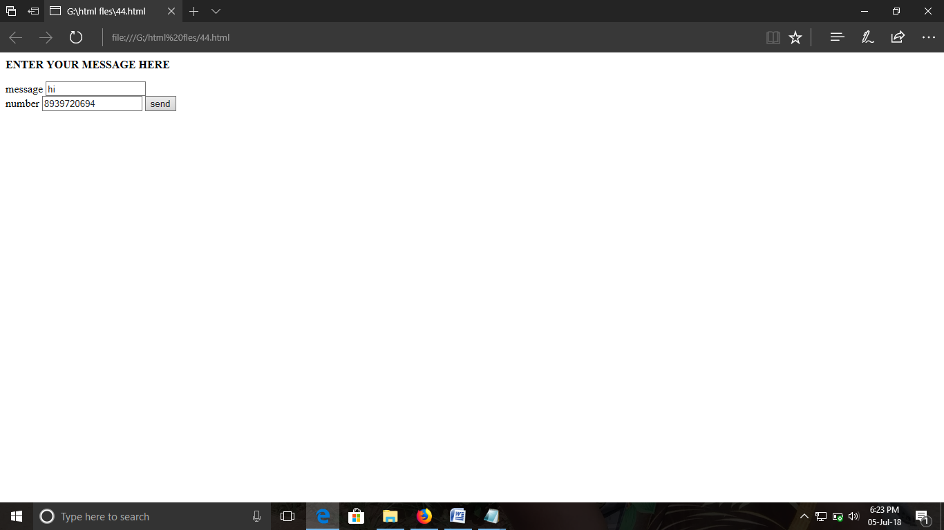

ExNo:41 /\*HTML CHECK BOX\*/

PROGRAM:

<html>

<head>

<style>

input[type=text]

{

background-color:red;

}

</style>

</head>

<body>

<p><b>CLICK YOUR GENDER HERE</b></p>

<div>

<form>

<label for="0">male</label>

<input type="checkbox" id="0" name="0"><br>

<label for="0">female</label>

<input type="checkbox" id="0" name="0">

<input type="submit" id="0" value="send">

</form>

</div>

</body>

</html>

OUTPUT:  
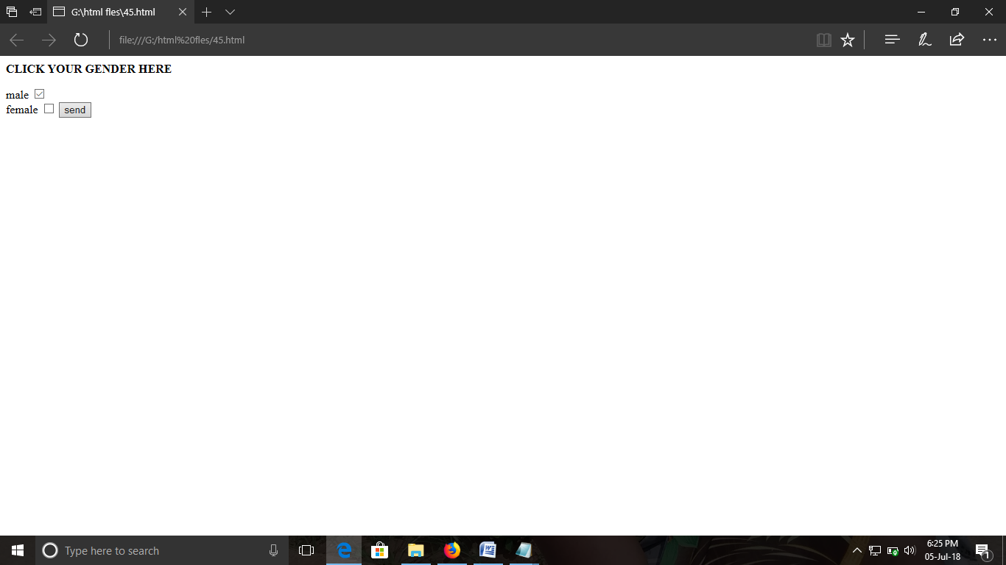

ExNo:42 /\*HTML RADIO BUTTON\*/

PROGRAM:  
<html>

<body>

<p><b>CLICK YOUR GENDER HERE</b></p>

<form>

<label for="0">male</label>

<input type="radio" id="0" name="0"><br>

<label for="0">female</label>

<input type="radio" id="0" name="0">

<input type="submit" id="0" value="send">

</form>

</body>

</html>

OUTPUT:

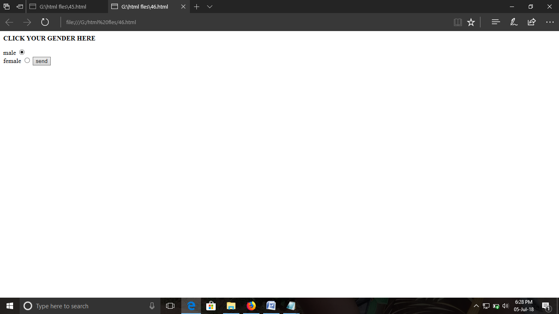

ExNo:43 /\*HTML SELECT\*/

PROGRAM:  
<html>

<head>

<style>

input[type=text]

{

background-color:red;

}

</style>

</head>

<body>

<p><b>CHOOSE YOUR LANGUAGE HERE</b></p>

<form>

<p>SELECT </p>

<select>

<option value="tamil">tamil</option>

<option value="english">english</option>

<option value="hindhi">hindhi</option>

<input type="submit" value="submit">

</select>

</form>

</body>

</html>

OUTPUT:

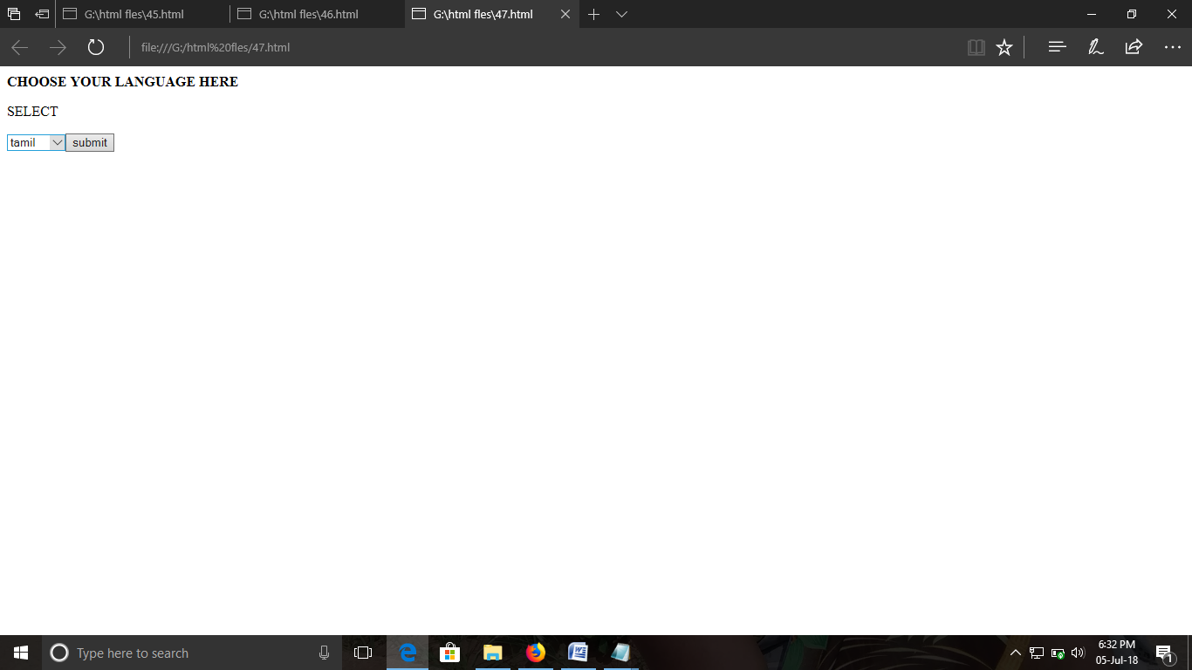

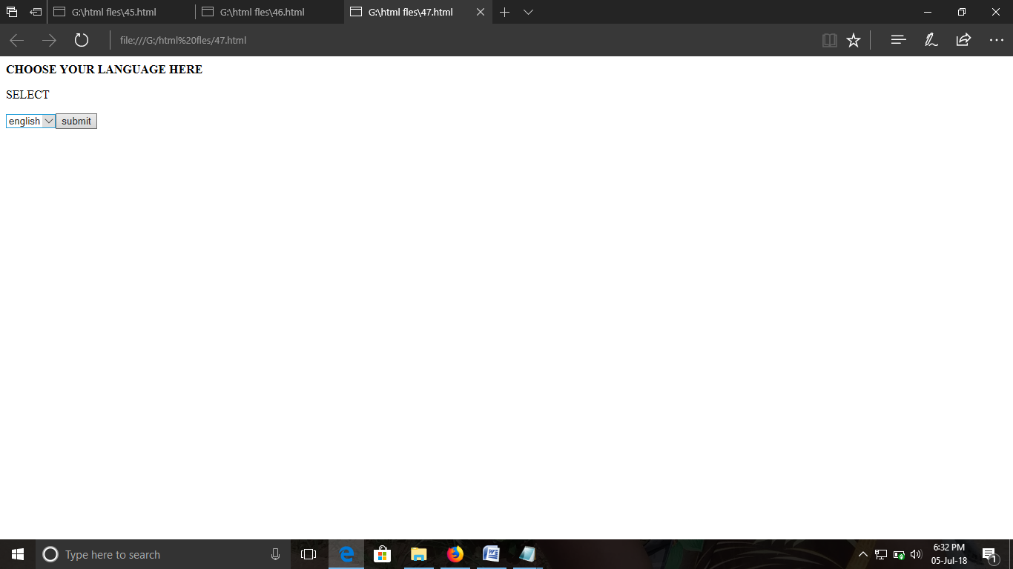

ExNo:44 /\*HTML HIDDEN FIELDS\*/

PROGRAM:  
<html>

<head>

<style>

input[type=text]

{

background-color:red;

}

</style>

</head>

<body>

<p><b>CHOOSE YOUR LANGUAGE HERE</b></p>

<form>

<p>SELECT </p>

<select>

<option value="tamil">tamil</option>

<option value="english">english</option>

<option value="hindhi">hindhi</option>

<input type="hidden" value="submit">

</select>

</form>

</body>

</html>

OUTPUT:

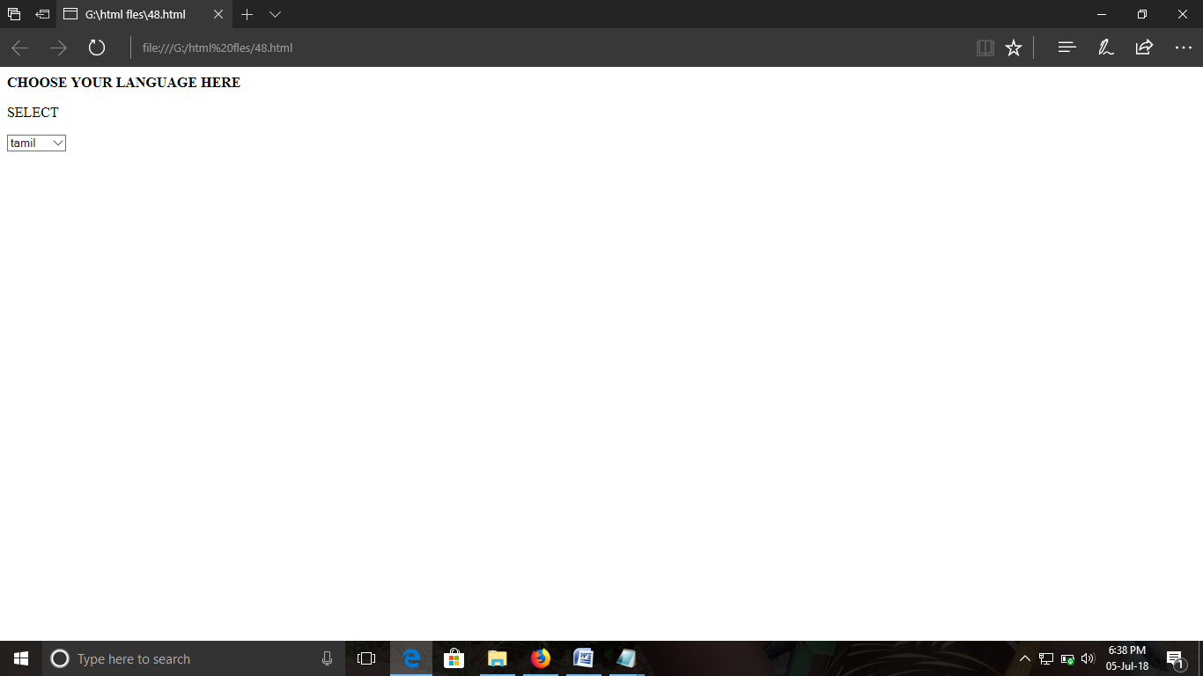

ExNo:45 /\*HTML FILE UPLOAD\*/

PROGRAM:  
<html>

<head>

<body>

<p>CHOOSE YOYR FILE HERE</p>

<forms>

<input type="file" >

</forms>

</head>

</html>

OUTPUT:

